**CP Club 365 Days Challenge**

**Programming language – C++**

**Problem Statement**

<https://leetcode.com/problems/merge-two-sorted-lists/>

Git :- <https://github.com/Vedantbharad2603/CP_club_365_Days>

**Your Code**:

// 0x97Day of 0x365Days challenge

// VEDANT BHARAD

// 22-1-2023

class Solution {

public:

    ListNode* mergeTwoLists(ListNode* list1, ListNode* list2) {

        ListNode *h1=list1,*h2=list2,*ret=list1,*temp;

        if(list1==NULL) return list2;

        if(list2==NULL) return list1;

        if(h1->val > h2->val)

        {

            ret=list2; swap(h1,h2);

        }

        while(h2)

        {

            if( (h1->next ==NULL)  || (h1->next->val > h2->val) )

            {

                temp=h2->next;

                h2->next=h1->next;

                h1->next=h2;

                h2=temp;

            }

            h1=h1->next;

        }

        return ret;

    }

};

**Output (Screen Shot)**:

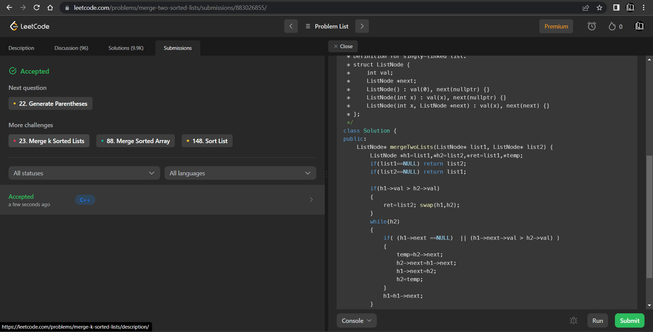

**Understanding about problem:**

* In this task I need to Merge Two Sorted Lists and and then return that list head.

Note: If you can't understand the problem, feel free to contact us and we'll help you. Please don't copy and paste from anywhere.

ALL THE BEST

Team CP Club